**STRATEGIA NETHERLANDS, INTERNATIONAL MANAGEMENT ORGANIZATION**

**ASSESSMENT OF STATUS OF SOLID WASTE MANAGEMENT PRACTICES**

**CASE STUDY: LIRA MUNICIPALITY-UGANDA**

**BY**

**OKELLO BONIFACE**

**PGD.WATER HYGIENE AND SANITATION (WASH)**

**A RESEARCH REPORT SUBMITTED TO DEPARTMENT OF WATER HYGIENE AND SANITATION (WASH) IN PARTIAL FULFILLMENT OF THE REQUIREMENTS FOR THE AWARD OF POST GRADUATE DIPLOMA OF WATER HYGIENE AND SANITATION (WASH) OF STRATEGIA NETHERLANDS, INTERNATIONAL MANAGEMENT ORGANIZATION**

**SUBMITTED ON DECEMBER 31st 2019**

**DECLARATION**

I Okello Boniface, hereby declare that this research is my very original work and to the best of my knowledge and faith has never been submitted to any academic for the purpose of awarding qualification. However the works of other authors have been respectfully consulted and acknowledged.

……………………………. …………………………

Signature Date

i

**Dedication**

This research project is dedicated to my son, Ojap Jayden Joshua and my mother who kept praying for me throughout the last one year. Her pray encouraged and kept me moving

ii

**ACKNOWLEDGEMENT**

First of all, I wish to give glory to the most high God, the Almighty God for his provisions, protection and grace that that has kept me this far.

I also acknowledge the tremendous contributions by Water for Lakes project, Mot MacDonald, and the Netherland embassy South Sudan and individuals supported me to make this academic dream a reality.

I acknowledge all the contributions of Strategia Netherlands international management organization and all the online moderators/ training consultants for the job well done.

And finally, I acknowledge the contributions and online good discussions by my course mates across the global. Thank you!

iii

**Acronyms/Abbreviations**

**CBOs**……..Community Based organizations

LM ……….Lira Municipality

LMC………Lira Municipal Council

SWM………Solid Waste Management

MSWM……Municipal Solid Waste Management

NEMA….National Environmental Management Authority

WB…………World Bank

US……. United States

EPA…..Environmental Protection Agency

ix

Contents

DECLARATION ........................................................................................................................................... i DEDICATION .............................................................................................................................................ii. ACKNOWLEDGEMENT ........................................................................................................................... iii ACRONYMS / ABBREVIATIONS............................................................................................................ ix ABSTRACT.................................................................................................................................................. x CHAPTER ONE ........................................................................................................................................... 1

1.0 Introduction......................................................................................................................................... 1

1.1 Background to the study ..................................................................................................................... 1

1.2 Statement of the problem .................................................................................................................... 2

1.3 Purpose of the study............................................................................................................................ 3

1.4 Specific objectives .............................................................................................................................. 3

1.5 Research questions.............................................................................................................................. 3

1.6 Significance of the study..................................................................................................................... 3

1.7 Definition of key terms ...................................................................................................................... 4,5

1.8 Scope of the study ............................................................................................................................... 6

CHAPTER TWO .......................................................................................................................................... 7

2.0 Literature Review................................................................................................................................ 7

2.1 Introduction......................................................................................................................................... 7

2.2 Status solid waste collection .............................................................................................................. 8

2.3 Transportation and disposal practices of solid waste .......................................................................... 9

CHAPTER THREE .................................................................................................................................... 10

3.0 Research Methodology ..................................................................................................................... 10

3.1 Introduction....................................................................................................................................... 10

3.2 Research design ................................................................................................................................ 11

3.3 Study Population and Area ............................................................................................................... 11

3.4 Sample Size....................................................................................................................................... 11

3.5 Sampling Techniques ........................................................................................................................ 11

3.6 Data Collection and data from primary sources …….........................................................................................................................................................12

3.8 Data Analysis .................................................................................................................................... 12

CHAPTER FOUR....................................................................................................................................... 13

4.0 Presentation and interpretation of findings ....................................................................................... 13

4.1 Introduction....................................................................................................................................... 13

4.2 Total respondents covered.................................................................................................................................................... 13

4.3 Bio-data of respondents.........................................................................................................................................13

4.4 Current status of solid waste in Lira Municipality......................................................... …………….18

4.4.1 Solid waste collection…………………………………………………………………………………………………………………18

4.4.2 Solid waste management practices .............................................................................................. 25

CHAPTER FIVE ........................................................................................................................................ 28

5.0 Summary, discussion, conclusions and recommendations. .............................................................. 28

5.1 Introduction....................................................................................................................................... 28

5.2 Summary and discussion of research findings .................................................................................. 28

5.3 Challenges associated with MSWM in LM........................................................................ ........ ….29

5.4 Strategies to overcome the Challenges to MSWM ………………………………………………….30

5.5 Conclusion and Recommendations................................................................................................... .30

5.6 Areas for further research ................................................................................................................. 30

REFERENCES ........................................................................................................................................... 44

APPENDICES .............................................................................................................................................. a

**LIST OF TABLES**

Table 4.1: Number of respondents................................................................................................. 13

Table 4.2: Age of respondents ..................................................................................................... 15

Table 4.3: Levels of education ...................................................................................................... 15

Table 4.4: Occupations of respondents ........................................................................................ 16

Table 4.5: Experience working in solid waste .............................................................................. 16

Table 4.6: Ranks to solid waste ................................................................................................... 17

Table 4.7 Solid Waste is regularly collected ................................................................................ 18

Table 4.8: Citizens use sacks to collect solid waste...................................................................... 20

Table 4.9: Solid waste is collected from generation to transfer / storage sites ............................. 21

Table 4.10: Curbside collection system is used in LM…………… ........................................... 21

Table 4.11: Transportation of solid waste is done by private company ....................................... 23

Table 4.12: Transportation of solid waste is done using appropriate equipments ........................ 23

Table 4.13: Open dumping spaces are commonly used as final disposal facilities ……. ...........25

Table 4.14: Recycling and composting are used in LM ………………………………………..26

Table 4.15: Land filling is used in solid waste disposal ............................................................... 27

**LIST OF FIGURES**

Fig 4.1: Gender Consideration ...................................................................................................... 14

Fig 4.2: Collection of solid waste in LM....................................................................................... 19

Fig 4.3: One week old uncollected wastes in LM………………………………………………19

Fig 4.4: Sacks filled with solid waste in LM………………....................................................... 20

Fig 4.5: Curbside is always used to collect waste in LM………………………………………..22

Fig 4.6: Appropriate transportation system for solid waste .......................................................... 24

Fig 4.7: Illegal dumping…………………………………………………………………………26

Fig 4.8: Disposing site/ Landfills ...................................................................................................27

**ABSTRACT**

Solid waste is one of the greatest challenges facing urban authorities across the globe; the amount wastes that are always generated exceeds the technical and financial capacities of most urban authorities, with majority being in developing countries. Therefore this study was conducted to assess the standard of solid waste management and practices, and to suggest possible strategies to address the challenges, with Lira Municipality in northern Uganda, being the case study.

Three specific objectives were raised to guide in establishing the standard and they included; To establish the current status of the solid waste collection, transportation facilities and disposal practices in Lira Municipality, to find out the challenges faced in the solid waste management in Lira Municipality, and to come up with possible strategies to address the solid waste management related problems in Lira Municipality.

A total of 41 respondents were reached through purposive and random sampling and interviews, questionnaires and observation methods were used during data collection. The participants were selected purposively due to their in depth knowledge of solid waste management and randomly selected to establish the quantities and waste management practices.

Data was well handled and analyzed using Statistical package for social scientists; the data was further analyzed in line with the study objectives and report presented is to reflect the general objective of the study

In line with the findings, several households, offices and public places including markets generate and collect wastes in plastic bags and sacks, which are sometimes illegally dumped later along the streets. Solid waste in Lira municipality is managed by the Municipal authority with little support from well wishers and nongovernmental organizations donating the tricycles that are being used to reach places that cannot be reached by the vehicle.

Conclusively, people still need to be reached with the message of clean environment, while the municipal authority has to lobby for more supports such as modern equipments and technologies in waste management. These supports can be better lobbied from the central government, private sectors and other nongovernmental organizations in order to cope up with the increasing challenges.

**CHAPTER ONE**

**1.0 Introduction**

This chapter introduces the research report. It starts with the background to the study, statement to the problem, research questions, scope and the significance of the study.

**1.1 Background to the study**

Globally, solid waste management continues to be the major challenge that is overwhelming the national and international capacity. According to WB report (Sept 2019), Annual waste generation is expected to rise by 70%, from 2.01 billion tones in 2016, to 3.40 billion tones by 2050. World Bank attributes this increment to rapid population growth and urbanization. It is believe that this will greatly affect developing countries. Uganda being among the developing countries is facing rapid urbanization due to mass rural to urban migration. Most cities in developing countries undergo accelerated urbanization and according to (Otoniel , Gerardo and Javier 2011) the biggest consequence is the change in consumption habit. Added that this change in the consumer’s habits results in the increased generation of wastes such as plastics and glass that are not degradable. This sharp rise in urban population has always affected the implementation of urban planning; there are so many slums in most urban centers across Uganda, with Lira municipality inclusive. The growth of these slums in Lira has hindered the development of waste management infrastructure, since some waste sites are inaccessible, while some households within those slums are practicing illegal dumping in those open spaces.

In Uganda, poor solid waste management can be attributed to low income, where some households are too poor or not willing to give priority to improved sanitation, while some households with low level of education, mostly those who have just migrated from the rural settings see no problems in dumping wastes inappropriately. It is also believe that families with large size generate a lot of wastes yet they don’t have a well laid system for proper waste disposal. Lira municipality has several categories of wastes that are classified as follows

Domestic wastes, which results from, household activities, such as food preparation, sweeping, cleaning, fuel burning/ash, garden wastes and plastics.

There are also commercial wastes, which are from markets, shops, offices, restaurants, hotels and other commercial establishments.

Institutional waste is mainly from such establishments as government offices, schools, hospitals, and other healthcare units, religious establishments and universities.

Lira municipality just like any other towns in Uganda, solid waste are disposed off in open places, near roadways, fields, along the stream and channels.

However it is important to note that Lira municipality in 2006 passed a bylaw titled SWM bylaw, to regulate all the waste management practices, and according to the bylaw, whoever dumps solid waste in an illegal way risks be persecuted or fined between 20000 to 40000 Ushs. In this bylaw, LM requires every trader and resident to take full responsibility of collecting garbage/ waste within their location and dumping it at the appropriate collection point. Lira municipality also has acquired land few kilometers from town, where composting takes places. But 13 years down the road, Lira municipality still experiences rampant illegal dumping along streets.

All these factors together with bad practices of illegal and dumping on open spaces are slowly causing environmental and health risks including contamination of surface and underground water, soil erosion due to the blockage along the sewerage channels/ drainages.

**1.2 Statement of the problem**

LMC experienced sharp population rise during the Lord Resistant Army that committed a lot of atrocities from 1986 to around 2005. This including other issues led to unplanned settlements, poor waste management and excessive waste generation. Lack funds, waste related infrastructures, lack of adequate technologies, and lack of proper solid waste management strategies have resulted into open waste / and or illegal dumping.

Open dumping of garbage has in most cases facilitated the breeding of diseases vectors such as flies, cockroaches, mosquitoes among others. And due to the above, Lira Municipality has always experienced high level of malaria outbreaks in the recent past years.

**1.3 Purpose of the study**

The purpose of this study was to assess the current status of solid waste management practices, related problems and strategies to address waste management challenges.

**1.4 Specific objectives**

i) To establish the current status of solid waste collection, transportation and disposal practices in Lira Municipality.

ii) To find out problems faced in solid waste management in Lira municipality

iii) To suggest possible strategies to overcome waste management related challenges in Lira Municipality.

**1.5 Research questions**

In order to achieve the above objectives, the following research questions were used:

i) What is the status of the existing solid waste collection, transportation and disposal practices in Lira municipality?

ii) What are the challenges faced in solid waste management in Lira municipality?

iii) What are the possible strategies to overcome waste management challenges in Lira Municipality?

**1.6 Significance of the study**

This study is very important to different stakeholders including the municipal dwellers, waste management worker, the Municipal authorities, central government specifically the national ministry of water and environment, ministry of health. In Uganda corruption where there is too much and always funds allocation for the municipal projects either diverted or embezzled by the official. This has always left sectors such as waste and sanitation sector affected, and the worst bit is that these officials always send good reports yet at the local level there are nothing done. Therefore this information may be used by relevant government, and other partners to come and fill the gap

**1.7 Definition of key terms**

**Wastes**

This study will be using the updated definition EPA (2019) waste means any discarded, rejected, abandoned, unwanted or surplus matter whether or not intended for sale or recycling, reprocessing or purification by a separate operation from that which produced the matter.

**Solid waste**

Still this study uses the EPA (2019) which defines solid waste as any garbage or refuses, sludge from wastewater treatment plant, water supply treatment plant and other discarded materials resulting from industrial, commercial, agricultural and community activities.

Another definition, which has also played a role in this study is by (Abdhala K, Blessing and Tilahun Nigatu 2016), which defined solid waste as all discarded solid materials resulting from households, industrial, healthcare, constructional, agricultural, commercial, and institutional sources.

**Municipal solid waste**

Municipal solid wastes are all the solid waste (excluding sewage, dissolved solids in the water, industrial waste) generated from the city or municipal (Abdhala K, Blessing and Tilahun Nigatu 2016). Therefore this study did not entirely relied on the definition by Peterson Obara Magutu and Cliff Ouko Onsongo (2010) in which they defined as solid waste that includes all domestic refuse, and non-hazardous waste such as commercial and institutional wastes, street sweeping and construction debris. This is because in most developing countries, including Uganda, and locally in Lira Municipality, most wastes are not sorted at source, collection, transportation and disposal.

**Solid waste management**

Waste management is the collection, transportation, processing, recycling or disposal and monitoring of waste materials (Peterson Obara Magutu and Cliff Ouko Onsongo 2010)

Solid or municipal solid waste management is also defined as the planning, financing and implementation of programs for solid waste collection, transportation, treatment and final disposal in, an environmentally and socially acceptable manner Abdhala K, Blessing and Tilahun Nigatu (2016).

**1.8 Scope of the study**

**Content**

This study aims and objectives were based on solid waste management status in Lira municipality; with more focus on waste generation practices, up to disposal or recycling points.

At a broader context, this study examined solid waste practices, collection, transportation and final disposal, and coming up with problems and possible strategies to address those problems that are associated with solid waste management Lira municipality.

**Geographical**

The study was conducted in Lira Municipality, located in Lira District, Northern Uganda

Lira municipality is a main administrative and business centre in northern part of Uganda. It is approximately 342 from Uganda main capital city- Kampala; it is about 6 hours drive from Kampala. According to Uganda bureau of Statistics 2014 (Uganda population census) Lira municipality had 99059 people. Many people come from the neighboring districts who are attracted by the socio-economic factors, but formal and informal hence increasing the population.

**Time**

The time scope of this study is between 1 December-31st December 2019, and Lira Municipality, being a big city, was increasingly experiencing great number of people. Being a festive season, December is always a very busy season for Lira municipality, since most people will be shopping for Christmas and as a result the rate of illegal waste dumping takes.

**CHAPTER TWO**

**2.0 Literature Review**

**2.1 Introduction**

**Defining solid waste**

This chapter presents the literatures that have been reviewed in regards to solid waste management, practices, the associated challenges and the strategies to overcome the challenges.

**2.2 The existing solid waste generation status**

Solid waste generation and urbanization are considered very close. According to Abdhala K, Blessing and Tilahun Nigatu (2016), global estimates indicated that by 2002, 2.9 billion urban residents generated about 0.64 kg of waste per person per day and by 2012, this rose to 1.2 kg per person per day with a total urban population of 3 billion. Currently, it is projected that by 2025 there will be about 4.3 billion urban residents who on average will generate 1.42 kg of waste per day. And it is estimated that by around 2025, 56 percent of the Africa’s population will be living in the urban centres.

Globally, China and India are experiencing highest rate of urbanization and waste generation as well, and without proper and improved solids waste management facilities, there are mush risks of environment-health rated problems, according to Abdhala K, Blessing and Tilahun Nigatu (2016)

Similarly, at a local municipal level, many human activities generate waste and these are major causes of environmental and health challenges including infectious diseases such malaria, cholera, dysentery, respiratory complications and injuries among others. The growing urban population means more solid wastes and higher impact on environment and health. Increased solid waste results into increased demand on existing solid waste management services, which are in many African countries, the single largest budgetary item for local governments, Abdhala K, Blessing and Tilahun Nigatu (2016)

Every municipal, city or town authority in the world is responsible for setting up a waste processing and disposal facility, and for preparing an annual report regarding the collection and improvement there under. The central governments and districts administration have the overall responsibility for enforcement of the provisions of the rules and regulations within territorial limits of their jurisdiction.

Municipal solid waste collection is currently one of the most critical lacking public services in slum areas in Uganda and its low coverage has caused public outcry. Factors that affect solid waste management in slums include inaccessibility, inability to pay where the service is expected to be paid for, and poor sanitation. The generation of solid waste is influenced by family size, education level, and income among other factors. The involvement of communities has a direct bearing on effective solid waste management and so do their awareness, attitudes, and practices. Participation is influenced by social pressures, environmental motivation, attitudes, and economic incentives.

Solid waste collection involves the pre -collection phase of waste transfer by the household member, or paid labor to the community collection points such as skips, bunker, and road sides. However on roadsides or open spaces Bartone (2001) says that this practice attract street children with hope of getting food from solid waste which make them malinger around the towns and cities competing for foods from the solid waste with such birds.

Waste collection from community points to the land fill or final dumping sites is always done by the urban / municipal authority and in some cases door-to door collection is always done on a private basis, James Okot- Okumu, and Richard Nyenje (2011).

Currently curbside solid waste collection is commonly used in different parts of the world, including Uganda. In Uganda, most cities have different sizes of containers that are kept by the city administration or other delegated private companies, near the street corners and street crossings and this is to enable householders dump or deposit their wastes which might have been generated in sacks, baskets, plastic bags. However in Uganda, most people carelessly end up dumping outside near the curbsides, hence littering the all surroundings. The worst of all is that in LM, due to financial challenges, lack of fuel, waste are not collected regularly making curbside full and overflowing.

Landfills usage in MSWM is very common in most developing countries; many of them are located in open spaces, wetlands which are not always protected. This has always attracted street children and other waste sorters to unlawfully access the sites and sort valuable materials for selling, and since most of these people don’t wear protection gears, chances are that they will contract environment health related diseases. Types of landfills include uncontrolled open dumps, controlled dumps and secure sanitary landfills. Uncontrolled open dumps are the least effective disposal of municipal solid waste in relation to appropriate local health and environmental standards.

**2.3 Transportation and disposal practices of solid waste**

Modes of transportation for MSWM practiced are: bullock carts, hand rickshaws, compactors, trucks, tractor, trailers, and dumpers. In smaller towns trucks having 5–9 ton capacity are used without adequate cover system. Stationary compactors, mobile compactors/closed tempos, and tarpaulin-covered vehicles are used in the transportation of MSW and about 65, 15, and 20% of waste is transported through these compacters, respectively. The maintenance of vehicles used in for transportation of waste is usually done in workshop run by Municipal authorities but most of these workshops can do minor repairs only. No wonder, in the event of breakdown of these vehicles, the overall collection, transportation, and disposal efficiency reduces drastically. Improper transport and disposal of solid wastes pollutes all the vital components of the living environment such as air, land and water at local and international perspective; this is because the collected solid wastes are composed of mixed paper, plastic, cloth, metal, glass and organic matter among others that are generated from households, and commercial establishments.

**CHAPTER THREE**

**3.0 Research Methodology**

**3.1 Introduction**

Research methodology is a path through which that researchers need to follow in conducting their research (Kassu Jilcha Sileyew 2019). It is a path through which the research problem and objective are formulated, and results from data obtained during the study are presented.

Therefore this chapter presents the research design and the approaches, the sample and sampling steps and procedures that were used during the study are described. It also presents in detail, the sources of information, data quality control, data processing and data analysis. For more clarification this chapter outlines Research design, population size and sample, data sources such as primary and secondary, data collection methods like observation, use of questionnaire, expert interviews and data quality control and analysis, among others.

**3.2 Research design**

A research design is defined as a master plan specifying the methods and procedure for collecting data, and analyzing the needed information (John Adams 2007). In addition, a research design must therefore ensure that the data collected is appropriate to solve the problems. The validity, reliability and generaliability of the research are all influenced by the methods, or design used to gather the information.

In this study, the researcher applied mixed methods and in a cross-sectional manner (gathering the data at once and classifying them simultaneously on clarification and their current response) , (John Adams, 2007).

The first part of the study consisted of well structured questionnaire which was meant to get clear information from management including engineering and environmental departments. The other research designed used is an interview where few households’ heads and street cleaners were interviewed on how they feel about solid waste management and the current status of waste management in Lira Municipality. The researcher also applied observation method especially at selected dumping sites. Therefore the research design helped the researcher to gather data from the wide range of respondents for a very short period of time, which finally helped in analyzing information.

**3.3 Study Area**

This study was carried out in Lira municipality, Lira District, located in northern Uganda, East Africa. Lira Municipality consists of four Divisions with the total population of 99,059 according of the Uganda national census of 2014 report.

**3.4 Population and sample Size**

The study population consisted of municipal officials and included engineer, environment officer, health inspectors and well as the waste sorters, site manager, the street cleaners, businessmen, officials from the nongovernmental organization department and different households’ representatives.

Due to limited time, only few people were randomly and purposively selected to participate in this study; and a total of 41 respondents were approached.

**3.5 Data Collection Methods**

This study used primary and secondary data collection techniques, focusing on both qualitative and quantitative data

**3.6.1 Data Collection from primary sources**

It’s worthy to note that primary data sources are both qualitative and quantitative. In this study, qualitative sources were the observation, interviews and information discussions with relevant stakeholders. And the quantitative data sources included survey questionnaires and detailed interview questions.

Under observation, the researcher was able to get deeper understanding on solid waste management especially at the household level, along the street and dumping sites, including the landfill and the related practices. Observation was used before the actual and after the data collection as a tool of generating more strong and valid information that were later used in producing this report.

More information were obtained through informal face-to- face interviews and this targeted the waste sorters, the street cleaners and the land fill/ site manager, with focusing of understanding the working environment and conditions of work. The later on gave opportunity to the above respondents to express their concerns where could not easily be captured through the survey questionnaires. All the information were recorded and transcribed, while considering the highest level of confidentiality.

Questionnaire was used as the main tool of gaining primary data, where each respondent was requested to consent first before the participation. To avoid biasness every respondent were given same identical questions which were later mixed, code and used in the analysis.

**3.6.2 Secondary Sources of Data Collection**

First of all secondary data refers to data that were collected and produced by somebody, not the user. In other wards it is public information that has been collected by someone and can be used as the foundation of the research. Here secondary data sources have been used to fill some information gaps that the researcher couldn’t obtain through the primary data sources.

**3.7 Data Analysis**

The quantitative data which were obtained from both primary and secondary sources as discussed about were analyzed using SPPS 16.0 version and word format as well. But before the analysis, there was thorough data cleaning, coding of responses, by classifying and assigning a numerical or character to a response.

Under the data analysis, the explanation has been made in descriptive statistics and graphical representations

**CHAPTER FOUR**

**4.0 Presentation and interpretation of findings**

**4.1 Introduction**

This chapter presents well interpreted findings of the study, as well as, the bio-data of respondents, the status of the current solid waste management, challenges and the possible strategies/ solutions to overcome.

**4.2 Total respondents covered**

The researcher was able to approach 41 respondents and 39 questionnaires were fully filled

Table 4.1: Total number of respondents

|  |  |  |
| --- | --- | --- |
| **Categories of questions** | **Frequency** | **Percentage** |
| No. of return | 39 | 95 |
| No. non return | 2 | 5 |
| **Total Supplied** | **41** | **100** |

The primary information presented in table 4.1 shows that 41 questionnaires were supplied to respondents, but only 39 copies which represent 95 percent were returned, while 2 copies which represent 5 percent were not returned. However this was a great success, because 95 percent has been big enough to give accurate significance of this study.

**4.3 Bio-data of respondents**

The bio-data of respondents which in this case include gender, age, level of education, respondent experience in waste management and occupation are well presented here

n. The study begins with gender as presented in the bar chart 4.1 of this chapter

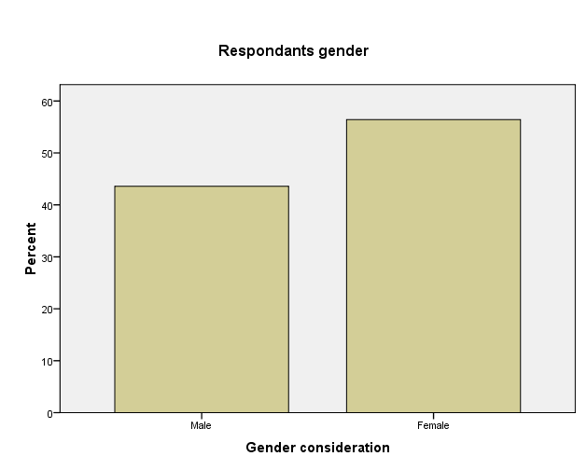

Fig 4.1: Gender Consideration

In the above bar chart 4.1, 54.6 percent of the respondents were females and 43.6 were males. This data represents the fact that men are always shy and not willing to get employment in waste management; they consider it to be a dirt work. In Lira municipality almost all street sweepers, garbage collectors are women. It was also found out that women are the solid waste collectors working in domestic and hotel settings. Only few men were seen in commercial, market places and some offices, as cleaners.

Finally on the above chart, more women were willing to spare their time for this study, were more employed at the waste management services, and they were always available at home and their waste related workplaces.

Age was yet another feature to describe the respondents as presented in Table 4.2 of this chapter

|  | | | | | |
| --- | --- | --- | --- | --- | --- |
| Age |  | Frequency | Percent | Valid Percent | Cumulative Percent |
| Valid | 18-30 | 2 | 5.1 | 5.1 | 5.1 |
| 31-40 | 16 | 41.0 | 41.0 | 46.2 |
| 41-50 | 4 | 10.3 | 10.3 | 56.4 |
| 51-60 | 12 | 30.8 | 30.8 | 87.2 |
| 61-above | 5 | 12.8 | 12.8 | 100.0 |
| Total | 39 | 100.0 | 100.0 |  |

Table 4.2: Age of respondents

As indicted in the above table 4.2, 41.0 percent of the respondents were between the age of 31-40 years, 30.8 percent were in the age group of 51-60, 12 percent were in the age group of 61 and above, 10.3 percent were falling in between 41-50, and the remaining 5.1 percent were within the young group of 18-30 years. It was realized that older people were more concerned and willing to be engaged in waste management services; most of them were older women who are working to earn a living.

Education was also captured as part of the bio data that would help in this study. This is presented in Table 4.3, below.

Table 4.3: Levels of education

|  | | | | | |
| --- | --- | --- | --- | --- | --- |
|  |  | Frequency | Percent | Valid Percent | Cumulative Percent |
| Valid | Secondary | 5 | 12.8 | 12.8 | 12.8 |
| Diploma | 6 | 15.4 | 15.4 | 28.2 |
| Degree | 5 | 12.8 | 12.8 | 41.0 |
| Post Degree | 4 | 10.3 | 10.3 | 51.3 |
| Others | 19 | 48.7 | 48.7 | 100.0 |
| Total | 39 | 100.0 | 100.0 |  |

According to the table 4.3 12.8 percent of the respondents had secondary education, 15.4 percent had diploma, while another 12.8 percent had degree level of education, and the remaining 48.7 included respondents with primary, technical and/ or no education at all. The Majority of the respondents assessed came from those who are normally engaged in collecting and transporting solid waste to either the generation points or to final dumping sites, in Lira Municipality.

The study also captured occupation information of the assessed respondents and the related findings are presented in the table 4.4 below in this chapter.

|  | | | | | |
| --- | --- | --- | --- | --- | --- |
|  | **Occupation** | Frequency | Percent | Valid Percent | Cumulative Percent |
| Valid | Environmental officer | 1 | 2.6 | 2.6 | 2.6 |
| Engineer | 2 | 5.1 | 5.1 | 7.7 |
| Land fill manager | 1 | 2.6 | 2.6 | 10.3 |
| Health inspectors | 4 | 10.3 | 10.3 | 20.5 |
| Other | 31 | 79.5 | 79.5 | 100.0 |
| Total | 39 | 100.0 | 100.0 |  |

Table 4.4: Occupations of respondents

According to the data presented in the table 4.4, respondents had different occupations. 79.5 percent of the respondents included professionals such as teachers, fuel station workers, and others such as businessmen/ women, housemaids/ wives and solid waste management operators. 10 percent of the respondents were division health inspectors of the four divisions that are within Lira Municipality. These are key people that are tasked with responsibilities of supervising and inspecting the health status of each division. 2.6 percent represents the land fill manager, who is tasked with the responsibility of coordinating and managing all the activities that take place at the land fill, while 5.1 percent of the respondents were municipal engineers who are responsible for all waste infrastructures for Lira Municipality, and the remaining 2.6 represents the municipal environment officer, whose views have helped a lot in this study. This study used the purposive and random sampling techniques to reach the respondents.

Year of experience was considered to be a very important millstone in assessing solid waste management in Lira Municipality and the results are presented in Table 4.5 of this chapter.

Table 4.5: Experience working in solid waste

|  | | | | | |
| --- | --- | --- | --- | --- | --- |
|  | **Experience in solid waste** | Frequency | Percent | Valid Percent | Cumulative Percent |
| Valid | Less or one year | 2 | 5.1 | 5.1 | 5.1 |
| Two year | 2 | 5.1 | 5.1 | 10.3 |
| Three years | 14 | 35.9 | 35.9 | 46.2 |
| Four years | 1 | 2.6 | 2.6 | 48.7 |
| Five years and above | 20 | 51.3 | 51.3 | 100.0 |
| Total | 39 | 100.0 | 100.0 |  |

The information presented in the table above shows that 51.3 percent of the respondents had five years and above experience, with solid waste management in domestic, commercial and other places, 2.6 percent had four years, 35.9 percent of the respondents had three years of experience with solid waste management, while 5.1 had two years of experience and the remaining 5.1 percent of the respondents had less or one year experience with solid waste management.

Part of this study also requested the respondents to rank the solid waste management services delivered prior or even during the study time, in Lira municipality. And rankings are presented in Table 4.6 below in this chapter.

Table 4.6: Ranks to solid waste management

|  | | | | | |
| --- | --- | --- | --- | --- | --- |
| Rank |  | Frequency | Percent | Valid Percent | Cumulative Percent |
| Valid | Excellent | 7 | 17.9 | 17.9 | 17.9 |
| Very good | 9 | 23.1 | 23.1 | 41.0 |
| Good | 2 | 5.1 | 5.1 | 46.2 |
| fair | 11 | 28.2 | 28.2 | 74.4 |
| bad | 10 | 25.6 | 25.6 | 100.0 |
| Total | 39 | 100.0 | 100.0 |  |

As presented in table 4.6 above, 28.2 percent of the respondents believed that solid waste management services in Lira municipality are fair, while 25.6 percent believed that the services are bad. 23.1 percent supported that the service is very good, with 17.9 percent of the respondents believing that the services are excellent, and the remaining 5.1 percent believed that solid waste management services in Lira municipality are good.

**4.4 The current status of solid waste management in Lira Municipality**

As earlier noted above, this study was designed to establish the current status of solid waste collection, transportation and disposal practices in Lira municipality. Therefore this section starts by presenting the status of solid waste collection that was established during the field study.

**4.4.1 Solid waste collection**

The aim was to find out whether or not the solid waste in Lira Municipality is being collected regularly.

Table 4.7 below presents the study findings.

| **Table 4.7 solid waste is regularly collected in Lira municipality** | | | | | |
| --- | --- | --- | --- | --- | --- |
|  | Ranking | Frequency | Percent | Valid Percent | Cumulative Percent |
| Valid | Strongly disagree | 8 | 20.5 | 20.5 | 20.5 |
| disagree | 22 | 56.4 | 56.4 | 76.9 |
| Neutral | 5 | 12.8 | 12.8 | 89.7 |
| Agree | 3 | 7.7 | 7.7 | 97.4 |
| Strongly agree | 1 | 2.6 | 2.6 | 100.0 |
| Total | 39 | 100.0 | 100.0 |  |

The information received from the field shows that solid waste is not collected regularly. This is confirmed by the views of 56.4 percent of the respondents who disagreed, while 20.5 percent in their views strongly disagreed with the statement that Lira municipality regularly collects solid wastes. On the other hand, 12.8 percent of the respondents neither disagreed nor agreed with the statement. While 7.7 percent agreed that solid waste in Lira municipality is regularly collected, and this was further supported by 2.6 percent of the respondents who strongly agreed that solid wastes are always collected as seen in fig 4.3 below.

Fig 4.2: Collection of solid waste in LM

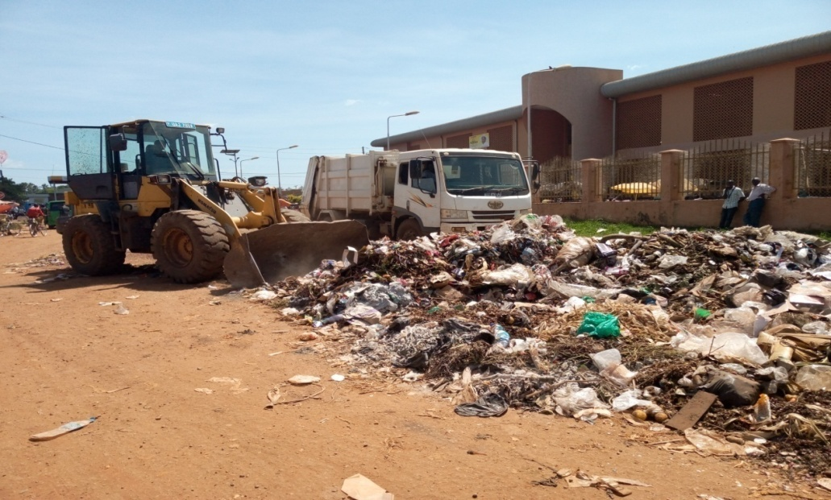

Fig 4.3 One week old uncollected wastes in LM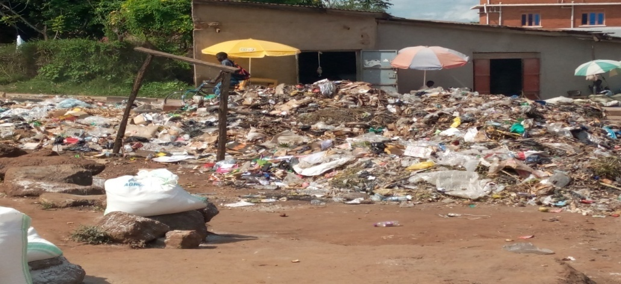

During the study, most sections of the streets in Lira municipality had uncollected solid wastes, with others as old as two to three weeks as seen in the above photo. Worst still is that these wastes are found in areas where they sell food and other edible stuffs, hence putting the lives of many at the risk of contracting diseases including diarrhea, dysentery among other.

This study also further established whether some people use sacks to collect or to manage solid wastes. And the results are presented and interpreted in table 4.4

|  |
| --- |

Table 4.8: People use sacks to collect a

|  |  | Frequency | Percent | Valid Percent | Cumulative Percent |
| --- | --- | --- | --- | --- | --- |
| Valid | Strongly disagree | 6 | 15.4 | 15.4 | 15.4 |
| Disagree | 5 | 12.8 | 12.8 | 28.2 |
| Neutral | 4 | 10.3 | 10.3 | 38.5 |
| Agree | 19 | 48.7 | 48.7 | 87.2 |
| Strongly agree | 5 | 12.8 | 12.8 | 100.0 |
| Total | 39 | 100.0 | 100.0 |  |

As indicted in the table 4.8 above, 48.7 percent of the respondents agreed that sacks are being used to collect and to manage solid wastes in Lira Municipality, while 12.8 percent of respondents strongly agreed. On the other hand `15.4 and 12.8 percents strongly disagreed and just disagreed respectively. While 10.3 percent of the respondents remained neutral during this study

Fig 4.4 Sacks filled with solid wastes in LM

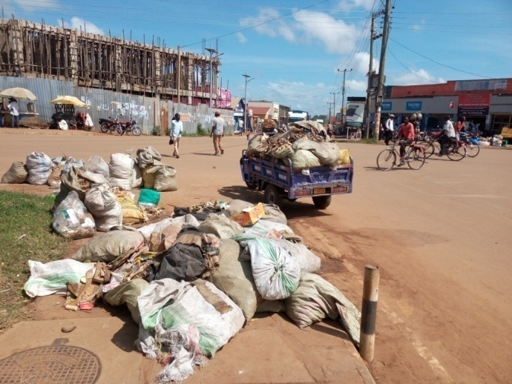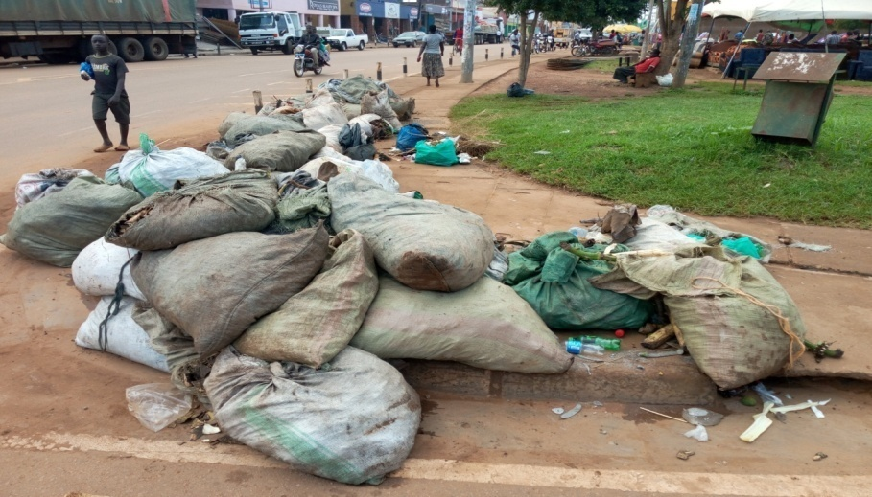

**Fig 4.4 sacks filled with solid waste being packed in a tricycle which delivers to a vehicle for transportation to land fill.**

During this study, the researcher found out that most of the households were using sack to collect the solid waste as seen in the fig 4.4 above.

Sacks were being filled with food remains especially at residential and restaurants premises, and later taken to the collecting sites, while other are left near the homes or along the road waiting for the vehicle. In some sections of the town, few tricycles were being used to transport these sacks to the dumping sites, or to the vehicles.

Another key area of concern was to establish whether solid wastes were being collected from the generation to transfer or storage site. The results are presented in the table 4.9 below

Table 4.9: Solid waste is collected from generation to transfer/storage sites

|  | | | | | |
| --- | --- | --- | --- | --- | --- |
|  |  | Frequency | Percent | Valid Percent | Cumulative Percent |
| Valid | Strongly disagree | 13 | 33.3 | 33.3 | 33.3 |
| Disagree | 19 | 48.7 | 48.7 | 82.1 |
| Neutral | 2 | 5.1 | 5.1 | 87.2 |
| Agree | 3 | 7.7 | 7.7 | 94.9 |
| Strongly agree | 2 | 5.1 | 5.1 | 100.0 |
| Total | 39 | 100.0 | 100.0 |  |

As presented in the table 4.9 above 33.3 percent of respondents strongly disagreed and 48.7 disagreed with the statement respectively. 5.1 percent of respondents were neutral, 7.7 percent agreed and another 5.1 strongly agreed with the statement.

In conclusion, the study actually established that majority of the respondents (48.7 percent) disagreed that solid waste in Lira municipality were not being collected from the generation points to other various storage or transfer sites.

Table 4.10: curbside waste collection system used in collecting solid waste

|  | | | | | |
| --- | --- | --- | --- | --- | --- |
|  |  | Frequency | Percent | Valid Percent | Cumulative Percent |
| Valid | Strongly disagree | 5 | 12.8 | 12.8 | 12.8 |
| Disagree | 14 | 35.9 | 35.9 | 48.7 |
| Neutral | 6 | 15.4 | 15.4 | 64.1 |
| Agree | 12 | 30.8 | 30.8 | 94.9 |
| Strongly Agree | 2 | 5.1 | 5.1 | 100.0 |
| Total | 39 | 100.0 | 100.0 |  |

In the table 4.10, 12.8 percent of respondents strongly disagreed and 35.9 percent disagreed with the statement. On the other hand, 15.4 percent were neutral, while 30.8 and 5.1 agreed and strongly agreed respectively.

Although majority were not using the curbside, but the researcher could observe the usage of curbside in some few areas of Lira municipality as captured in fig 4.5 below.

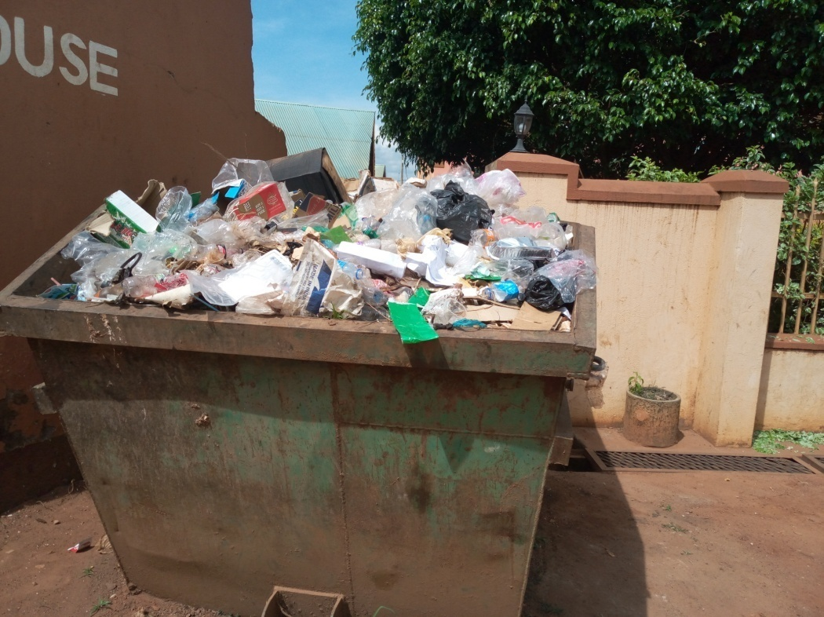

Fig 4.5: the usage of curbside in LM

**4.4.2 Solid waste transportation**

And important area that was quantitatively established was the solid waste transportation in Lira municipality; the findings are presented in the table 4.11 below

Table 4.11: Transportation of solid waste

|  | | | | | |
| --- | --- | --- | --- | --- | --- |
|  |  | Frequency | Percent | Valid Percent | Cumulative Percent |
| Valid | Strongly disagree | 21 | 53.8 | 53.8 | 53.8 |
| Disagree | 13 | 33.3 | 33.3 | 87.2 |
| Neutral | 2 | 5.1 | 5.1 | 92.3 |
| Agree | 2 | 5.1 | 5.1 | 97.4 |
| Strongly agree | 1 | 2.6 | 2.6 | 100.0 |
| Total | 39 | 100.0 | 100.0 |  |

The findings presented in the table 4.11 shows that 53.8 percent of respondents strongly disagreed and 33.3 percent disagreed with the statement respectively. While 5.1 percent were neutral and another 5.1 percent agreed and 2.6 percent strongly agreed with the statement that solid waste transportation in Lira municipality were being done by the private company.

| The study also focused further on whether the appropriate equipment was being used in Lira municipality for solid waste transportation. And the results are presented in the table 4.12 below |
| --- |

Table 4.12: Appropriate equipments are being used in Lira municipality for solid waste transportation

|  |  | Frequency | Percent | Valid Percent | Cumulative Percent |
| --- | --- | --- | --- | --- | --- |
| Valid | Strongly disagree | 13 | 33.3 | 33.3 | 33.3 |
| disagree | 18 | 46.2 | 46.2 | 79.5 |
| Neutral | 4 | 10.3 | 10.3 | 89.7 |
| Agree | 2 | 5.1 | 5.1 | 94.9 |
| Strongly Agree | 2 | 5.1 | 5.1 | 100.0 |
| Total | 39 | 100.0 | 100.0 |  |

The findings as indicted in the table 4.12 shows that 33.3 percent of respondents strongly disagreed with more 46.2 disagreeing with that statement that appropriate equipments were being used in transporting solid waste in Lira Municipality. While 10.3 percent remained neutral, with 5.1 percent and another 5.1 percent of respondents agreed and strongly agreed with the statement.

The researcher was able to conclude that although Lira municipality uses appropriate equipments as seen in fig 4.6 below, people’s justifications were based on their regularity and effectiveness in transporting the solid waste. Many people were actually heard saying “***that it is better not to have than to have equipments which are faulty and broken or grounded down ’’.***

The vehicle presented is one of the equipments considered as appropriate for solid waste transportation.

**Fig 4.6: Appropriate equipments that were being used in solid waste transportation in Lira municipality.**

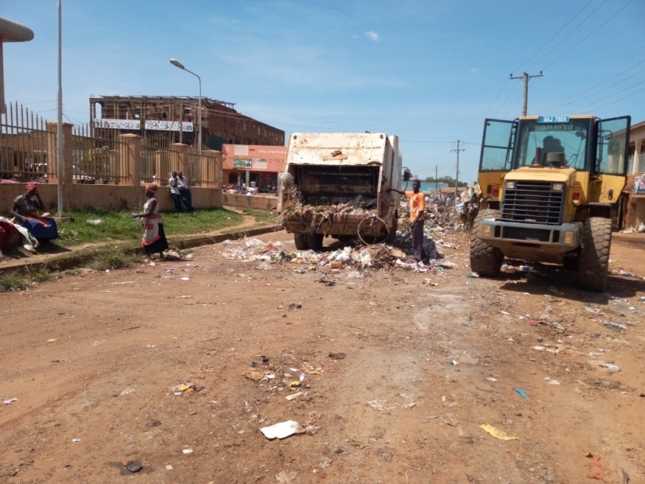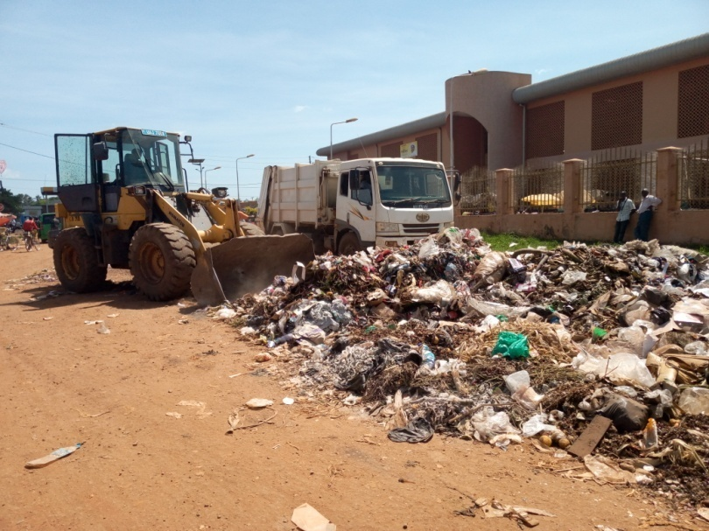

Fig 4.6: Appropriate equipments used for SW

As indicated in the fig 4.6 above, Lira municipality has equipments that are always used in transporting solid wastes. These vehicles are always operated and accompanied by waste collectors and other sorters who help in the process of transportation

**4.4.3 Solid waste disposal practices**

Through the study, it was established that Lira municipality experiences different solid waste disposal practices and this was confirmed by responses received, presented and interpreted in table 4.13 below.

**Table 4.13: Open dumping spaces are commonly used as final disposal facilities**

| **Open dumping spaces are commonly used as final disposal facilities** | | | | | |
| --- | --- | --- | --- | --- | --- |
|  |  | Frequency | Percent | Valid Percent | Cumulative Percent |
| Valid | Strongly disagree | 2 | 5.1 | 5.1 | 5.1 |
| disagree | 7 | 17.9 | 17.9 | 23.1 |
| Neutral | 7 | 17.9 | 17.9 | 41.0 |
| Agree | 16 | 41.0 | 41.0 | 82.1 |
| Strongly agree | 7 | 17.9 | 17.9 | 100.0 |
| Total | 39 | 100.0 | 100.0 |  |

The information presented the table 4.13, shows that 5.1 percent of respondents strongly disagreed that open spaces are not commonly used as final disposal facilities. 17.9 percent of respondents further disagreed with the statement. Further still, another 17.9 percent remained neutral about the statement, while 41.0 percent and another 17.9 percent of respondents agreed and strongly agreed that open dumping spaces were commonly being used as final solid waste disposal facilities, respectively. In line with this, it was realized that although people don’t practice dumping in open place as final disposal points, but major sections of the population were using open spaces as their final solid waste disposal points, a habit that causes health and environmental risks to other population. Seen in fig 4.6 below

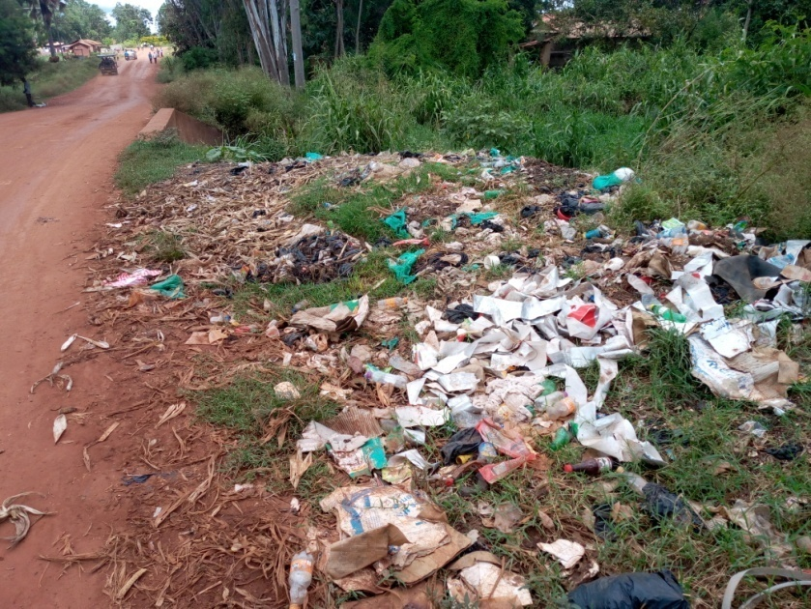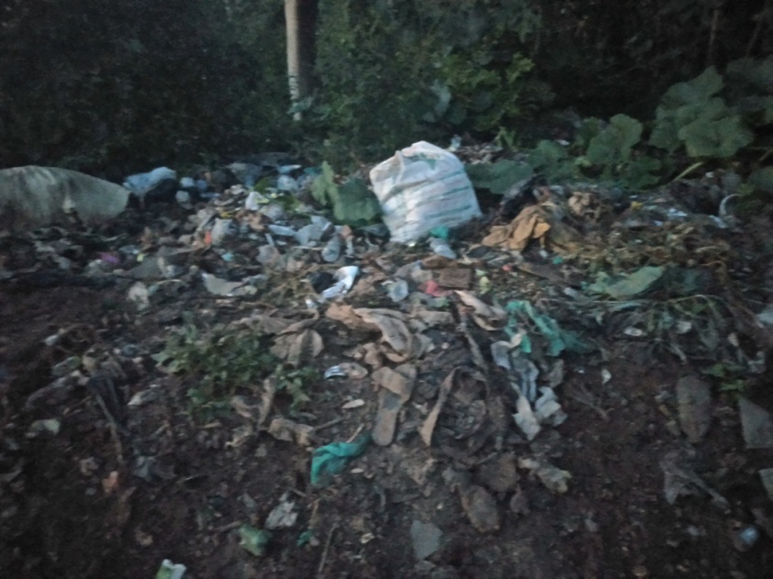

Fig 4.7: Illegal dumping in open spaces .

This study also gave much emphasis in establishing whether Lira municipality was also practicing recycling and composting in solid waste management, and responses received are presented in table 4.14

**Table 4.14 Recycling and composting of solid waste in Lira municipality**

|  | | | | | |
| --- | --- | --- | --- | --- | --- |
|  |  | Frequency | Percent | Valid Percent | Cumulative Percent |
| Valid | strongly disagree | 6 | 15.4 | 15.4 | 15.4 |
| Disagree | 10 | 25.6 | 25.6 | 41.0 |
| Neutral | 11 | 28.2 | 28.2 | 69.2 |
| Agree | 7 | 17.9 | 17.9 | 87.2 |
| Strongly agree | 5 | 12.8 | 12.8 | 100.0 |
| Total | 39 | 100.0 | 100.0 |  |

The information in the table 4.14 presents 15.4 percent of respondents who strongly disagreed that recycling and composting are done in Lira municipality. 25.6 percent disagreed with the statement, 28.2 percent were neutral, while 17.9 percent agreed and the remaining 12.8 percent of respondents strongly agreed with the statement. Descriptively the results show that the higher number (28.2), although remained neutral, but to a larger extent lacked information about solid waste recycling and composting that take place in Lira municipality.

Respondents were also requested to give their views about land filling activities in Lira municipality and their responses are presented in table 4.15

**Table 4.15 Land filling used in solid waste management, in Lira municipality**

| **Land filling is used in the solid waste management** | | | | | |
| --- | --- | --- | --- | --- | --- |
|  |  | Frequency | Percent | Valid Percent | Cumulative Percent |
| Valid | Strongly disagree | 1 | 2.6 | 2.6 | 2.6 |
| Disagree | 5 | 12.8 | 12.8 | 15.4 |
| Neutral | 6 | 15.4 | 15.4 | 30.8 |
| agree | 21 | 53.8 | 53.8 | 84.6 |
| Strongly agree | 6 | 15.4 | 15.4 | 100.0 |
| Total | 39 | 100.0 | 100.0 |  |

As presented in table 4.15, 2.6 percent of respondents strongly disagreed and 12.8 also agreed that land fill is being used in Lira municipality. 53.8 percent of respondents agreed, while 15.4 strongly agreed that Lira municipality uses land fill in solid waste management and the remaining 15.4 were neutral to the statement. Although many agreed that land fill is being used, but the researcher observed that it uses poor technologies; many waste sorters don’t have protective gears, therefore wastes not sorted, while much wastes were being dumped outside the landfill, hence posing major health problems to underground waters and human lives.

Fig 4.8: Landfill in Lira municipality

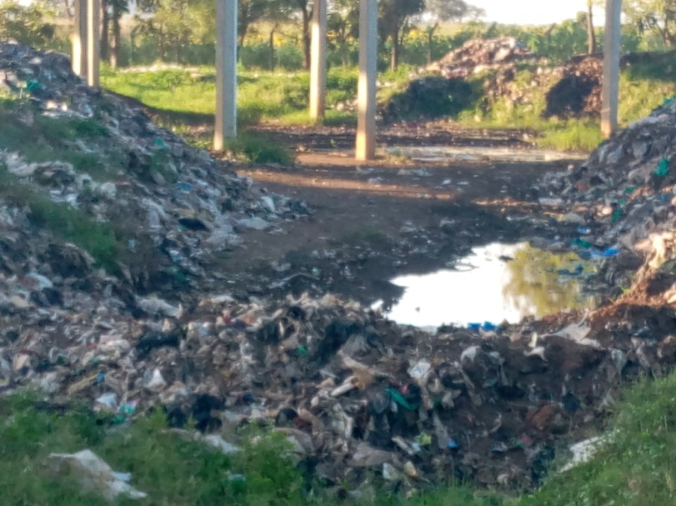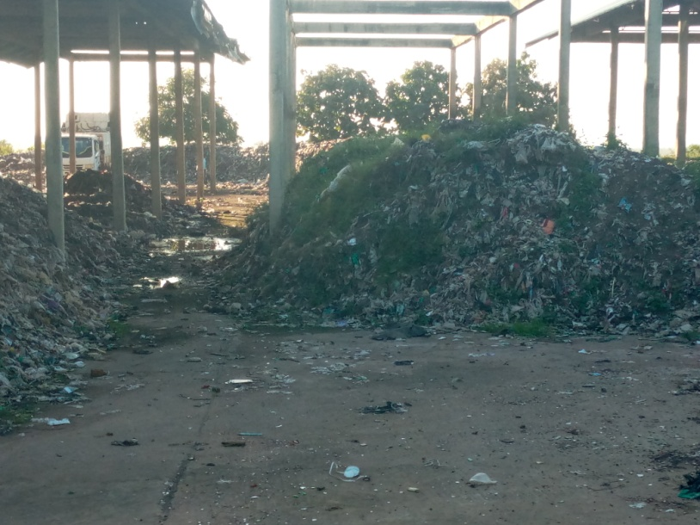

**Solid waste in the land fill Solid waste dumped outside the land fill,**

**CHAPTER FIVE**

**5.0 Summary, discussion, conclusions and recommendations.**

**5.1 Introduction**

This chapter involves summary of findings, conclusion and recommendations. The summary is based on the findings on the study objectives and the recommendations are based on the discussion of the findings and analysis as well as interpretation of the findings addressing the research questions that the study aimed to answer.

**5.2 Discussion of research findings**

**The rate of solid waste management problems**

The majority of respondents in LM didn’t sort the waste before the final disposal. Wastes were generated from food, plastics, papers, metal wastes and others of which were dumped inappropriately. Most households dumped their wastes in open places, burning in their compounds and throwing to ditches, along the rivers and the road sites, partly because of informal settlements which were not accessible by the big vehicles.

In general the study established that stressing challenges to solid waste management in Lira municipality are poor planning, attitude, rapidly growing urban population, mindset and perception of the people. Other related challenges are inadequate institutional/ infrastructural facilities, shortage of expertise, financial resources, legal and administrative handle the rising problems and to enforce the environmental regulations respectively.

All in all, due to financial constraints, Lira municipality occupants lack health and environmental awareness, since the concerned departments don’t have the capacity to create the awareness. And as a result, waste generators end up littering and un controlled waste which are in most cases dumped inappropriately leak in to water bodies, or congesting the open spaces with flies and odour.

In many of these communities, poor management of solid waste contributes to flooding, air pollution, and spreading of diseases and health conditions such as respiratory ailments and diarrhea, giving rise to severe economic and social losses. The problems are particularly severe in slums in developing countries where the solid waste management systems are inadequate.

The study has noticed that the prevalence of diseases is due to the incubation and proliferation of flies mosquitoes and rodents which are vectors that end up affecting the community members around the open dumping places.

**5.3 Challenges associated with MSWM in LM**

In summary as was the purpose of this study to establish the challenges associated with MSWM and come up with few possible strategies,

First challenges in LM is inappropriate dumping of plastic/ non biodegradable which results in clogging of drainage channels, creating water pools convenient for mosquito breeding and generating nuisance of smell. Plastics collection and disposal practices observed among slum residents in this study create difficulty for recollection, recycling, and profitable reuse by recycling companies and individuals.

Lack of waste segregation at source which leads to various environmental problems and it becomes very difficult to segregate waste at transfer station or in landfill or treatment site. This is due to lack of public awareness, participation in waste segregation at door-to door collection and appropriate disposal bins.

Unplanned settlement in LM is yet another challenge to MSWM; due to 21 years (1986-2003) of Rebel activities in Northern Uganda, people were allowed to settle in a much unplanned way, just to response to emergency. But after the insurgencies, most people refused to leave the way for a better and planned development; they all need to be compensated or fully relocated to places. And at the end, big truck/ vehicles can’t reach some of these settlements to collect the generated wastes. Besides, it is becoming very hard for LM MSWM department to plan for the adequate waste facilities in some of those unplanned settlements.

LM has limited landfills that cannot accommodate the ever increasing solid waste due to overwhelming urban population. Due to financial problem, LM can’t expand or construct new land fill to overcome the solid waste challenges.

There is also resistance of local citizen for notification of landfill site in their locality and therefore selection of new site is difficult and yet the existing landfill sites are running beyond their capacity.

**5.4 Strategies to challenges of MSWM in Lira Municipality**

Providing incentives for separation and collection of plastics and other materials is a possible strategy.

Similarly involving more women/ girls in MSWM by setting different initiatives targeting improving solid waste management should therefore consider the dominant role played by women and girls in the management of solid wastes.

The people should be educated to realize the importance of source segregation at generation point as biodegradables, inert and recyclable material for proper waste management.

Solid collection and disposal points should be made available in public domain. Government should take initiative to encourage Universities, technical Institution to take up waste management in its curriculum.

The waste should be treated as resource and formal recycling sector/industries be developed to recycle non-biodegradable recyclable component from the waste thereby providing employment to rag-pickers and absorb them in mainstream. Also a policy, fiscal intensive and development of quality standard for reuse and recycle of C&D waste be developed and notified so that producers dispose/reuse it as per guidelines, thereby reducing burden on landfill.

Manufacturing of non-recyclable polyethylene bags should be banned or research should be initiated to develop biodegradable polyethylene.

**5.5 Conclusion and Recommendations**

The study showed that, on average more than 60% of respondents/ residents practice improper solid waste management. Lack of adequate knowledge about solid waste management and lack of access to door-to door facilities affected solid waste collection as reported.

Therefore, there is a need for enhancing the awareness of solid waste management at the community level (using both NGOs/ CBOs and media houses) and the accessibility of door to door solid waste collection service

**5.5 Areas for further research**

➢ The affordability and the sustainability of 4Rs approach in most Uganda’s cities Institutional Capacity for Sustainable Solid Waste Management.

**REFERENCES**

A review and framework for understanding the potential impact of poor solid waste management on health in developing countries. (n.d.).

Abdhalah K. Ziraba, T. N. (2016). A review and framwork for understanding the potential impact of poor solid waste management on health in developing countries.

John Adams, H. T. (2007). *Research Methods for Graduate Business and Social science students.*

LeBlanc, R. (2019). An Introduction to Solid Waste Management . *Briefing Paper* .

NEMA-Uganda. (2016/2017). *Annual performance Report.* Kampala.

Okot-Okumu, J. (2011). Solid waste management in African cities- East Africa.

-

**APPENDICES**

**Appendix 1: Map of the study area**

**Appendix 2;Questionnaire**

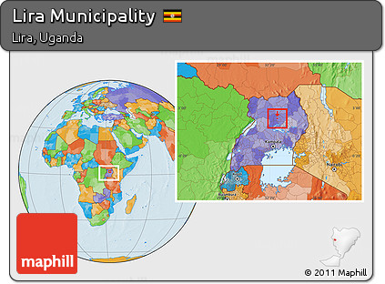

Lira Municipality, in northern part of Uganda, East Africa.

b

**Appendix 2: Research questionnaire**

Dear Respondent,

I am a student of Strategia management Organization based in Netherlands- pursuing post graduate diploma in Water sanitation and Hygiene. As part of the academic requirements, I am carrying out a research on “**An Assessment of status of Solid Waste Management Practices; A case study of Lira Municipality -Uganda”.**

You have been randomly selected and kindly requested to spare your time to participate in this assessment. Your information will be kept confidential, and will only be used to produce the academic report in relation to the above study.

Would like to continue? Yes or No

**SECTION A:**

**General information**

1. Title/ position:

………………………………………………

2. Age range

|  |  |  |  |  |
| --- | --- | --- | --- | --- |
| a) | 18-30 | c) 41-50 |  | e) 61 and above |
| b) | 31-40 | d) 51-60 |  |  |
| 3. | Gender  a) Male |  | b)Female |  |

4. Your level of education

|  |  |  |
| --- | --- | --- |
| a) Secondary | c) Degree | e) Other (specify)………… |
| b) Diploma | d) Post Degree |  |

5. Your occupation

a) Envtal officer c) Land fill Manager

b) Engineer d) Health inspector

e) Other (Specify): ……………………………………………………………...

6. Your experience in solid waste management

|  |  |  |
| --- | --- | --- |
| a) Less or One year | c) Three years | e) Five years and above |
| b) Two years | d) Four |  |

**SECTION B**

7. How do you see solid waste management related services in Lira municipality?

a) Excellent c) Good d) Bad b) Very good d) Fair (f) Dk

8. How is solid waste collected in Lira municipality?

a) Door-to-door collection

b) Communal collection

c) Others

………………………………………………………………………………………

………………………………………………………………………………………

9. Please indicate the extent to which you agree with the statements where (1 = Strongly disagree; 2 = Disagree; 3 = Neutral; 4 = Agree; and 5 = Strongly agree).

|  |  |  |  |  |  |  |
| --- | --- | --- | --- | --- | --- | --- |
|  | **Statement** | **1** | **2** | **3** | **4** | **5** |
| 9 | Solid waste is regularly collected in Lira Municipality |  |  |  |  |  |
| 10 | People use sacks and plastic bags to collect solid waste. |  |  |  |  |  |
| 11 | Solid waste is collected from generation to the transfer/storage sites. |  |  |  |  |  |
| 12 | Curbside is always used to collect solid waste |  |  |  |  |  |
| 13 | There is always Recycling and composting of waste in Lira Municipality |  |  |  |  |  |
| 14 | Transportation is done by a private company. |  |  |  |  |  |
| 15 | Transportation of solid waste is done using appropriate equipments. |  |  |  |  |  |
| 16 | Open dumping spaces are commonly used as final disposal facilities. |  |  |  |  |  |
| 17 | Recycling and composting are carried out in Lira municipality |  |  |  |  |  |
| 18 | Land filling is used in the solid waste management. |  |  |  |  |  |
|  |  |  |  |  |  |  |

**SECTION C:**

20. State the problems associated solid waste collection in Lira Municipality.

…………………………………………………………………………………………

…………………………………………………………………………………………

21. What are the problems associated with transportation.

…………………………………………………………………………………………

…………………………………………………………………………………………

…………………………………………………………………………………………

22. What challenges are associated with the disposable points?

………………………………………………………………………………………

………………………………………………………………………………………

………………………………………………………………………………………

……………………………………………………………………………

22. Is there any other problem associated with solid waste management in Lira Municipality?

a) Yes b) No

If yes, mention them

………………………………………………………………………………………

………………………………………………………………………………………

………………………………………………………………………………………

23. Suggest strategies to be used in overcoming challenges of waste management in

Lira Muncipality

…………………………………………………………………………………………

…………………………………………………………………………………………

…………………………………………………………………………………………

**Thank you for your cooperation**